Haroutun Haroutunian

Professor Berhe

ECE 442L

27 October 2021

Lab 1 MyDAQ

**Schematic Lab 1 MyDAQ:**

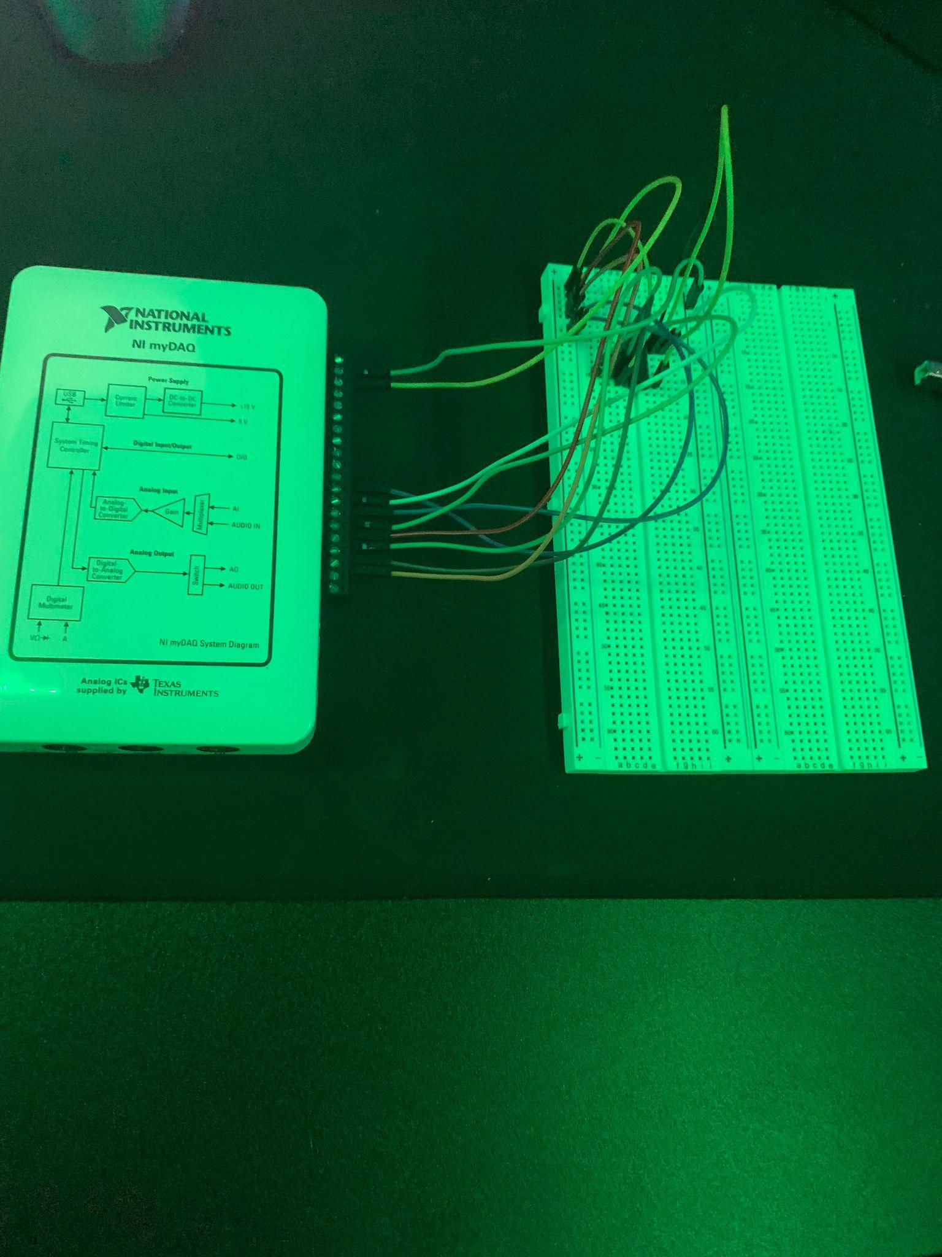

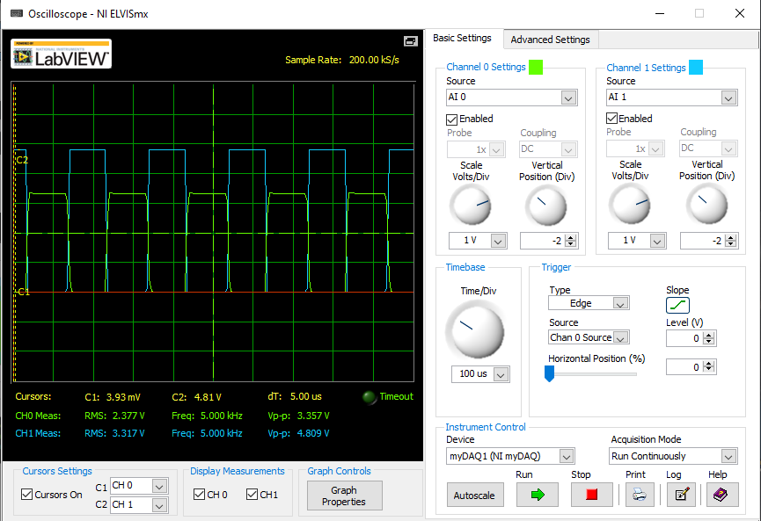

**Figure 1.1 MyDAQ Circuit**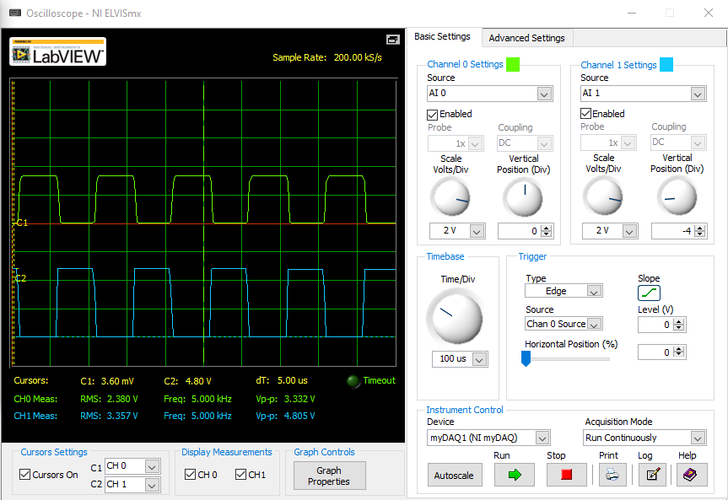

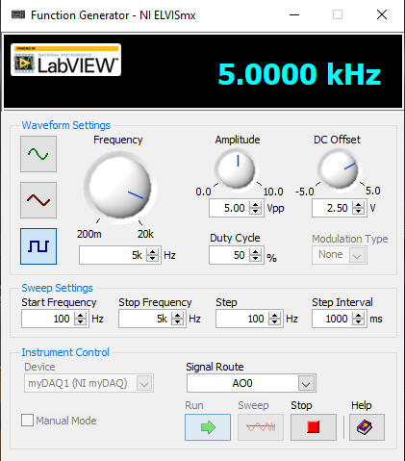

**Figure 1.3Overlapped Waveform for CMOS Inverter 5V rectangular Input Case 2 for f = 5kHz**

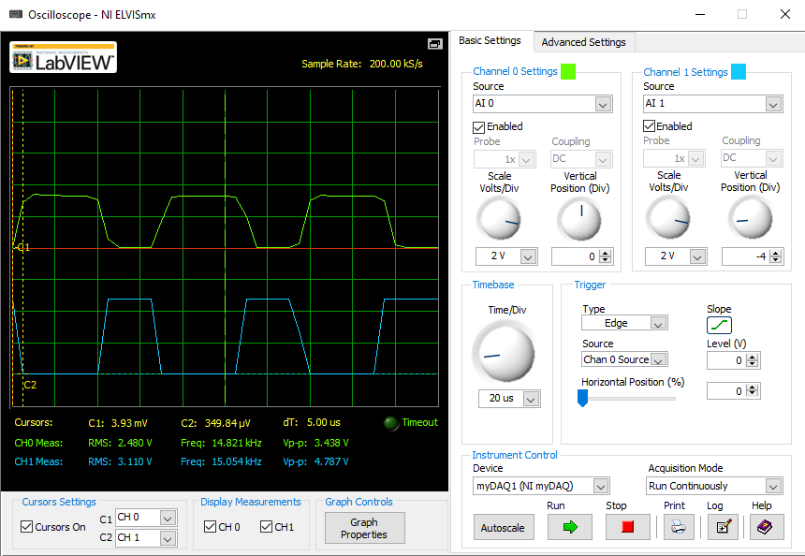

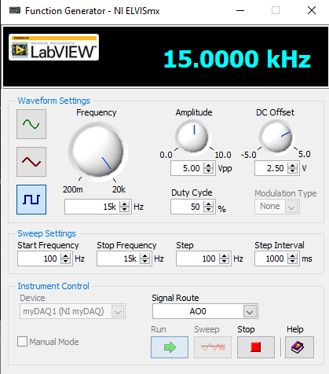

**Figure 1.2 Waveform for CMOS Inverter 5V rectangular input Case 2 for f=5 kHz**

**Figure 1.4 Waveform for CMOS Inverter 5V rectangular input case 4 for f=15kHz**

**Figure 1.5 Overlapped Waveform for CMOS inverter 5V rectangular input case 4 for f=15kHz**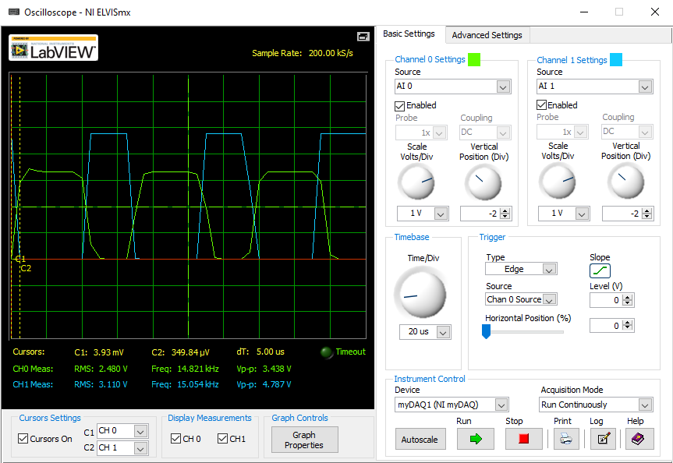

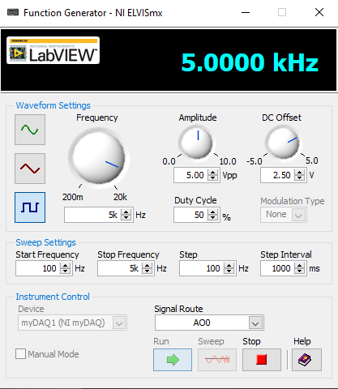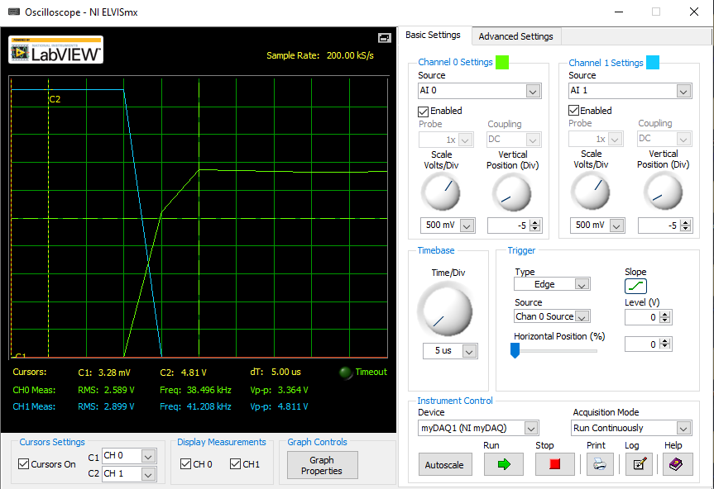

**Figure 1.6 Waveform for Case 2 CMOS inverter Propagation Delay HIGH to LOW for f=5kHz**

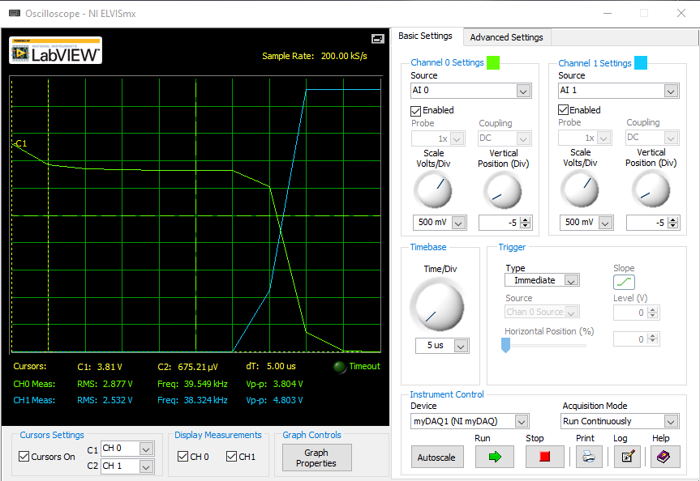

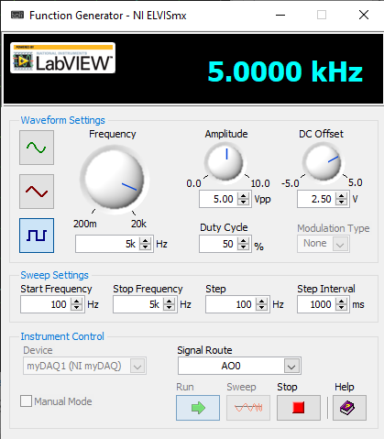

**Figure 1.7 Waveform for Case 2 CMOS inverter Propagation Delay LOW to HIGH for f=5kHz**

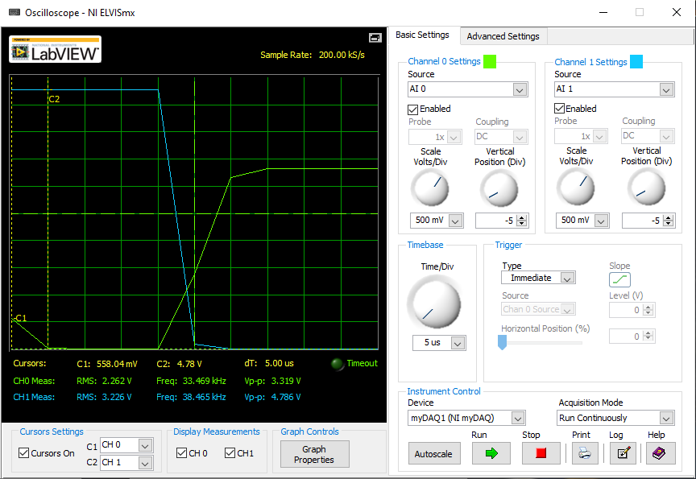

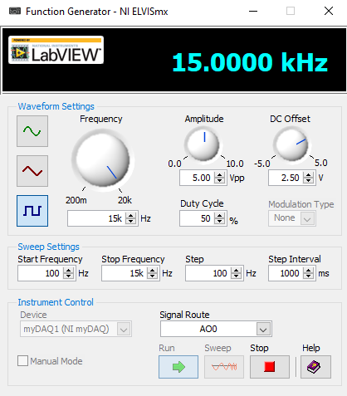

**Figure 1.8 Waveform for Case 4 CMOS inverter Propagation Delay HIGH to LOW for f=15kHz**

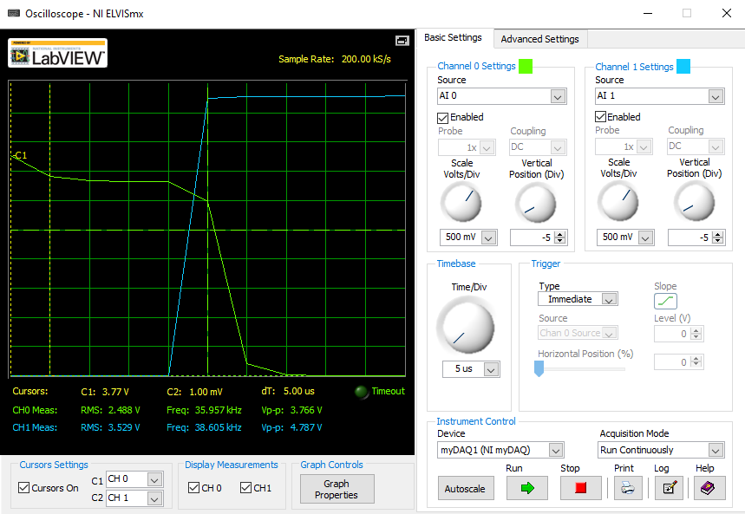

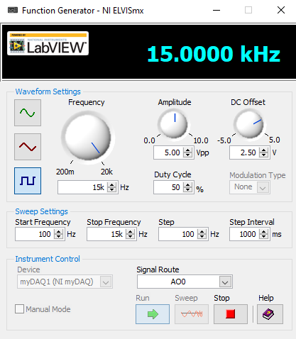

**Figure 1.9 Waveform for Case 4 CMOS inverter Propagation Delay LOW to HIGH for f=15kHz**

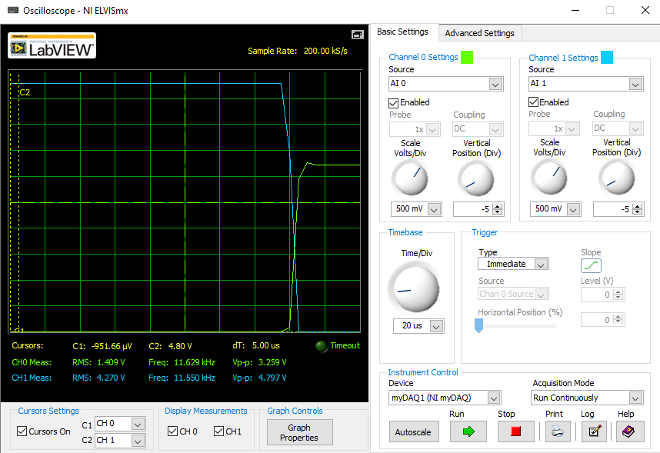

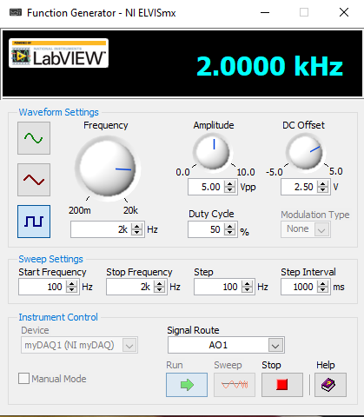

**Figure 1.10 Waveform for ramp case 2 CMOS Inverter voltage transfer for triangular Wave for f = 2kHz and Slope = 4.14V**

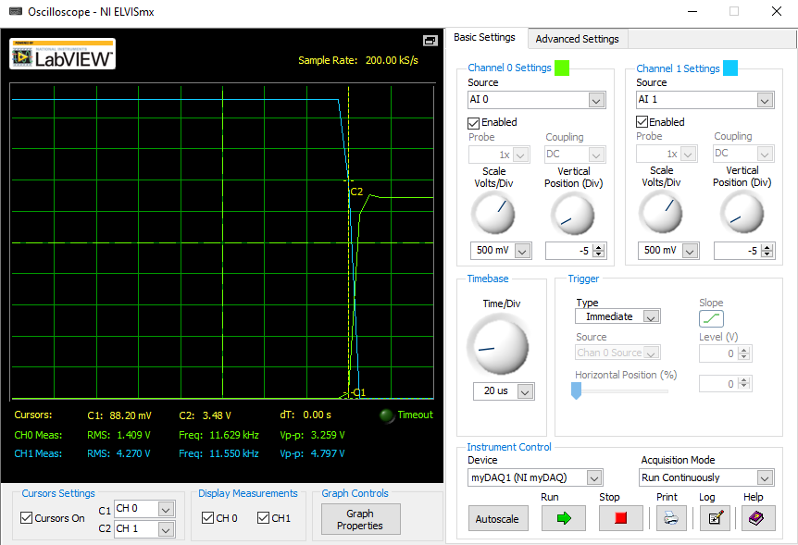



**Figure 1.11 Waveform for ramp case 2 CMOS Inverter voltage transfer for triangular Wave for f = 2kHz and Slope = 0.3 V**